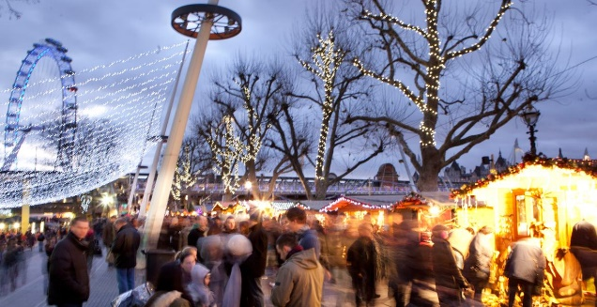

Winter Market

**Date and Time:** 9 Nov-27 Dec, from 11am

**Location:** Southbank Centre, Queen's Walk, under Hungerford Bridge

**Price:** Free

**Description:** Eat, drink and be merry beside the River Thames at Southbank’s Winter Market. Expect seasonal goodies, sparkling lights, mulled wine and that festive feeling.

Over six weeks they have two new food and drink pop-ups: Bar Under the Bridge is a warm hideaway serving cheese-themed food with cocktails such as ‘Blood Orange Paloma’, ‘Red Snapper’ and ‘Prosecco Fred’. The Circus Bar is pitching up in front of Royal Festival Hall. Warm up with friends and family in this cosy space with sizzling fire-pits.

Alongside the pop-ups, traders from around the world bring to the riverside an array of handmade festive goodies and delicious street food. Each trader brings their unique spin to the feast, with stalls offering Asian, Indian and Greek cuisines, traditional winter favourites like raclette and bratwurst, and sweet treats including waffles and pancakes.

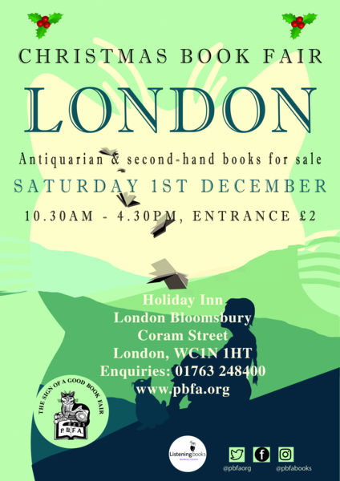

London Christmas Book Fair

**Date and Time:** Saturday 1 December, 10:30am-4:30pm

**Location:** Holiday Inn London - Bloomsbury, Coram Street, London WC1N 1HT

**Price:** £2

**Description:** It’s Christmas and you are stumped for gift ideas. You want to give not just a present but the right present. Perhaps the adventurous chef in the family might appreciate an old handwritten recipe book. Or for the traveller, a tale of exploration in the Artic wastes. You can find them all at the Provincial Booksellers Fairs Association’s Christmas Book Fair. Whatever your interests, be assured that there will be something here to whet your appetite.

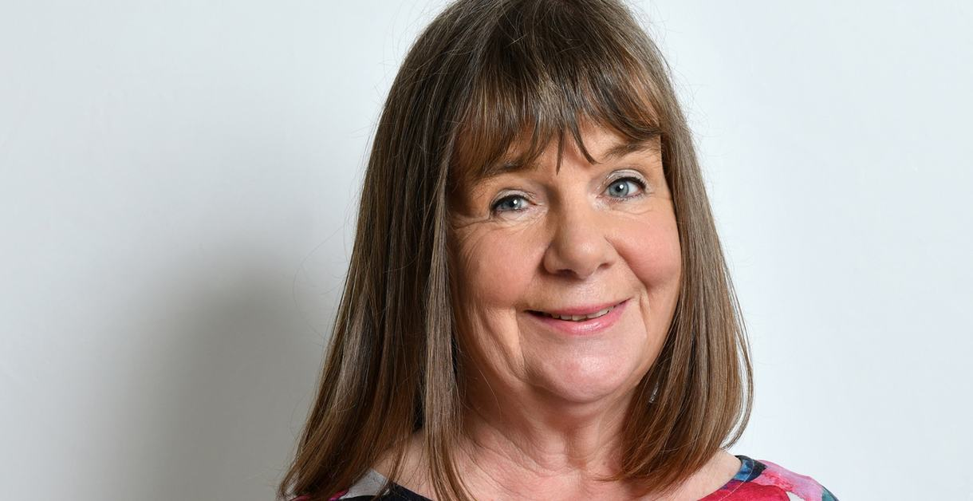

Julia Donaldson & Axel Scheffler's Zog & Friends Show

**Date and Time:** Sunday 2 December, 11am

**Location:** Queen Elizabeth Hall

**Price:** £15 Adult, £7 Child (Booking fee £3)

**Description:** Join the UK’s number one picture book pair for the ultimate festive sing-along show for families – with songs, stories and live drawing.

In this event, the creators of Zog, Julia Donaldson and Axel Scheffler, celebrate some of the much-loved stories that inspired the magical Zog films, ahead of the animated Zog Christmas special.

Be on the lookout for Zog, The Highway Rat, The Gruffalo and more favourite characters.

Books are sold by Foyles after the show, and the authors are happy to stay and sign them – with appearances from the costume character of Zog.

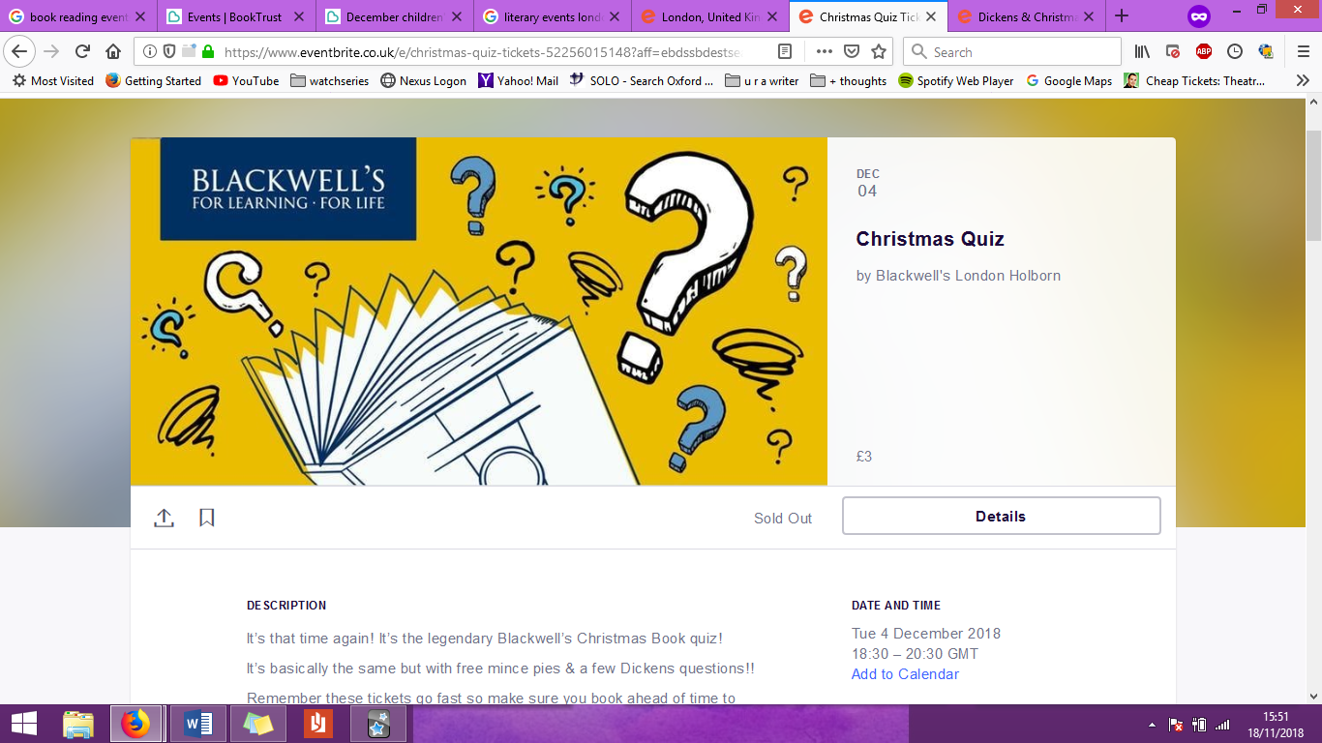

Blackwell’s Christmas Book Quiz

**Date and Time:** Tue 4 December 2018, 6:30–8:30pm

**Location:** Blackwell's Bookshop (Holborn), 50-51 High Holborn, London WC1V 6EP

**Price:** £3

**Description:** It’s that time again! It’s the legendary Blackwell’s Christmas Book quiz!

It’s basically the same but with free mince pies & a few Dickens questions!!

Remember these tickets go fast so make sure you book ahead of time to avoid disappointment. Rules remain the same, as follows...

* Bottle of wine for Best Quiz Team Name (as chosen by quizmaster Gary)

* Maximum of four quizzers per team - please book a ticket per quizzer at the price of £3 each

* Bring Your Own Bottle - we will provide you with wine glasses and cups

* Spot prizes of books will be awarded on the night, and the grand prize is £10 per quizzer in Blackwell's vouchers!

Any questions drop us a line at [Events.London@Blackwells.co.uk](mailto:Events.London@Blackwells.co.uk)

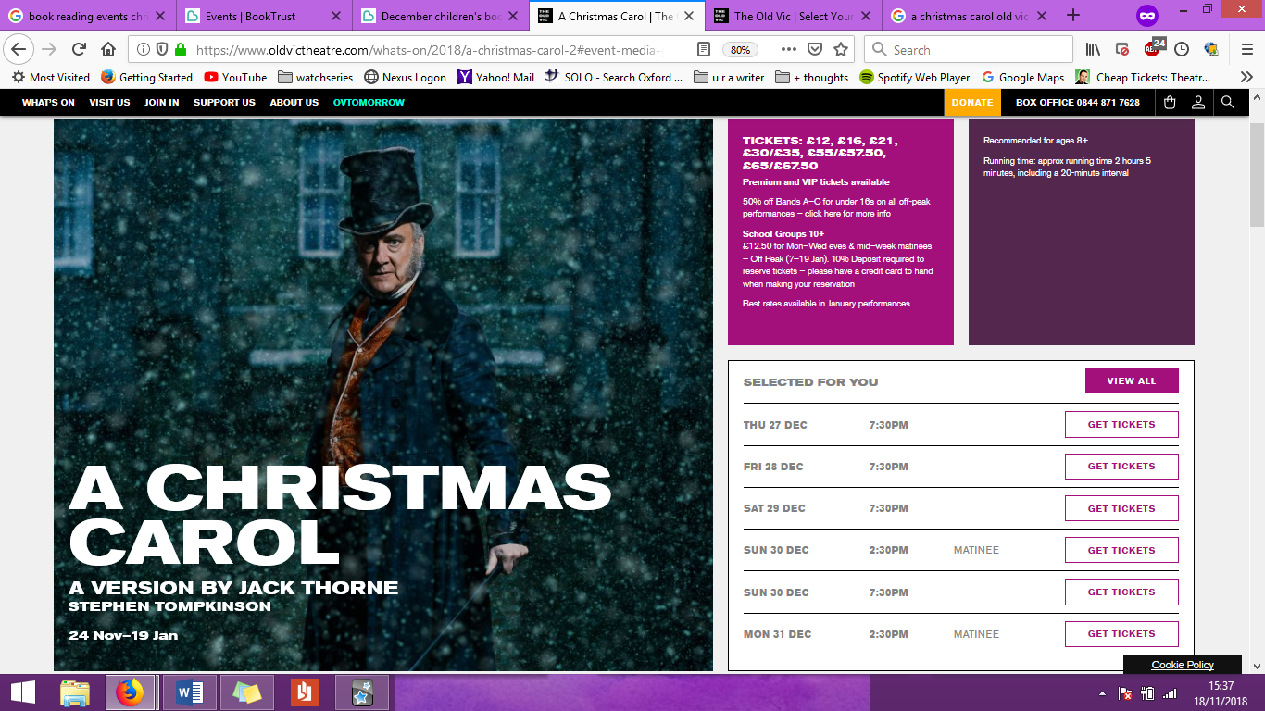

A Christmas Carol

**Date and Time:** 6 December-19 January, performances at 2:30pm and 7:30pm

**Location:** Old Vic Theatre

**Price:** Tickets from £12

**Description:** A CHRISTMAS CAROL RETURNS BY POPULAR DEMAND

Matthew Warchus’ big-hearted, smash hit production of Charles Dickens’ immortal classic A Christmas Carol returns to The Old Vic with previews from 24 November, joyously adapted for the stage by Jack Thorne (Harry Potter and the Cursed Child).

Filling the auditorium to the brim with mince pies, music and merriment, a unique staging immerses the audience in this uplifting story for everyone aged 8+.

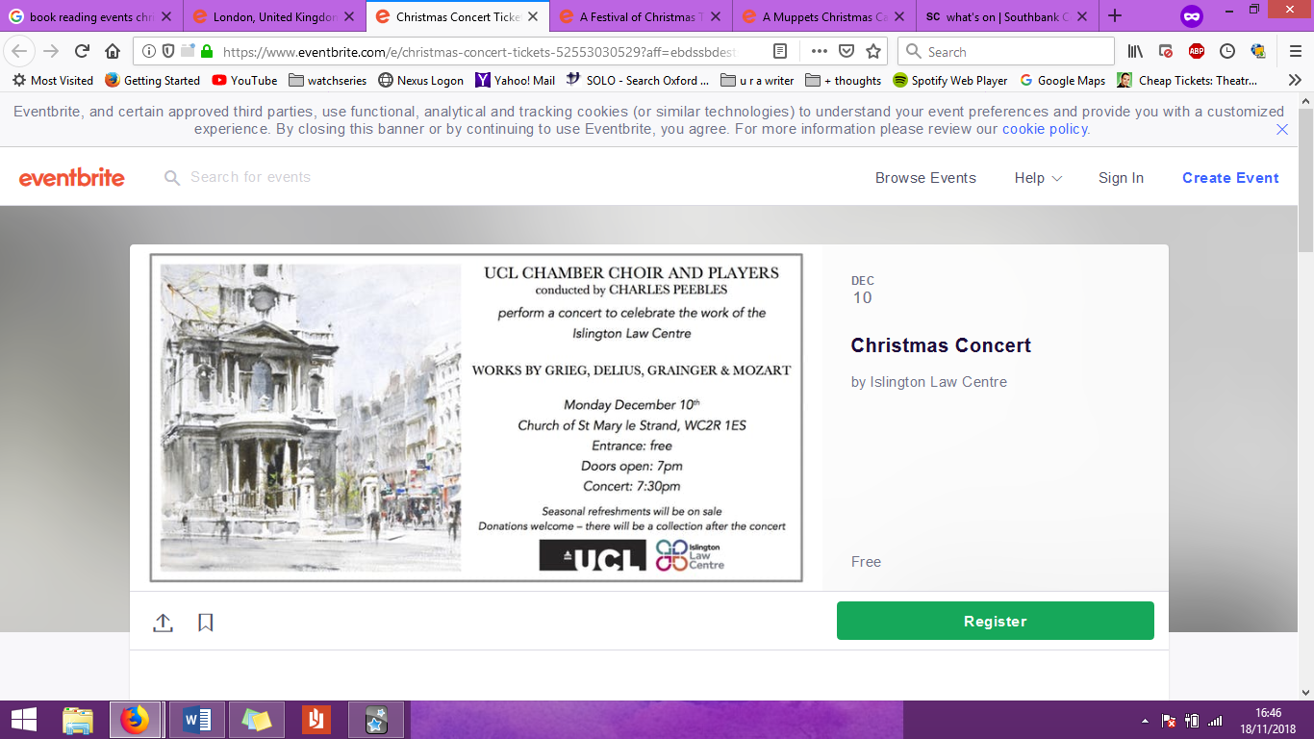

Christmas Concert

**Date and Time:** Mon 10 December, 7:30-9pm

**Location:** St Mary Le Strand Church, London, WC2R 1ES

**Price:** Free

**Description:** The UCL Chamber Choir and Players are performing a concert in aid of Islington Law Centre. This is a wonderful opportunity to come together to celebrate the start of the Christmas season and to support access to justice for those in Islington who are at the sharp end of poverty and inequality.

The concert is free but all donations will help Islington Law Centre in its critical mission to protect the rights of vulnerable people.

Seasonal refreshments will be on sale.

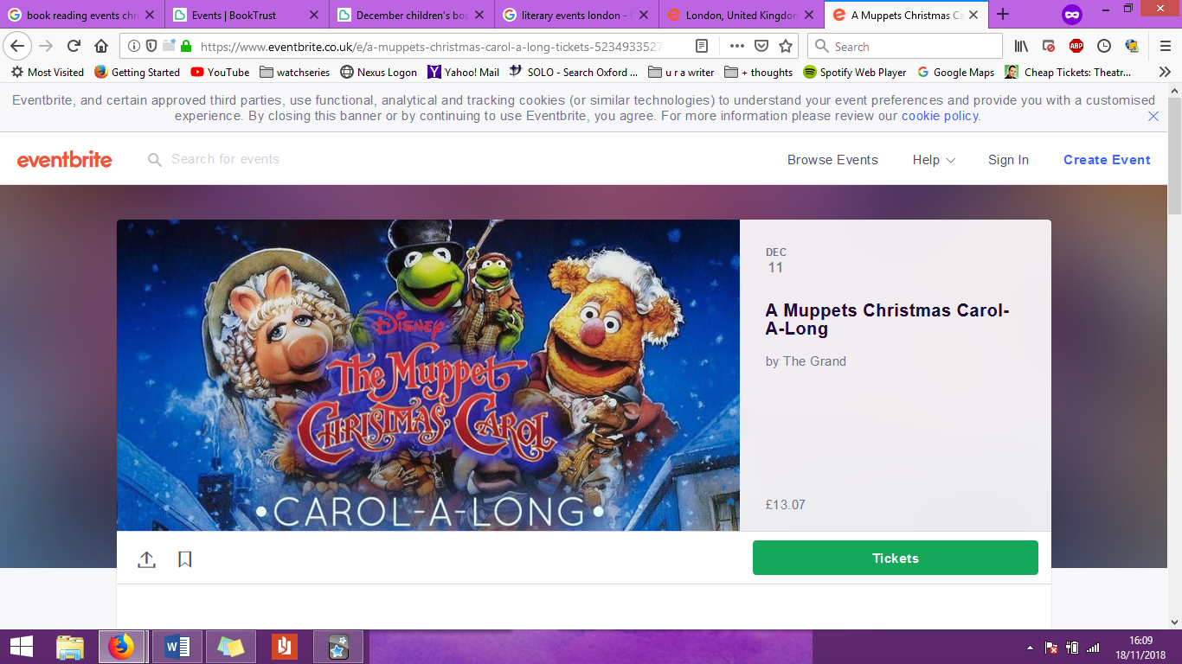

A Muppets Christmas Carol-A-Long

**Date and Time:** Tue 11 Dec 2018, 6– 9:30pm

**Location:** The Grand, 21-25 Saint John's Hill, London SW11 1TT

**Price:** £13.07 (£10 + £3.07 booking fee)

**Description:** Join us for the greatest literary adaptation of all time. You read right, OF ALL TIME. WITH MUPPETS.

What’s not to love? Michael Caine is the ultimate Scrooge, Gonzo and Rizzo are narrators and there’s a host of singing vegetables, because what good film doesn't feature singing vegetables?

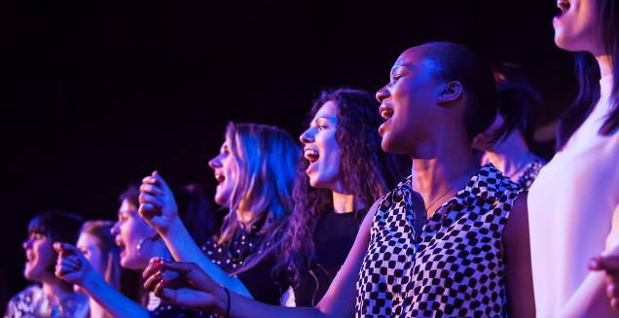

Winter Choirs

**Date and Time:** 11 Dec-23 Dec, performances at 1pm, 1:30pm and 5:45pm

**Location:** Queen Elizabeth Hall

**Price:** Free

**Description:** No silent nights at our festive season of free 30-minute performances from community choirs, with a few sing-alongs, too!

From seasonal songs, to classical, choral, jazz and pop, choirs of all shapes and sizes serenade audiences throughout the run-up to the holidays.

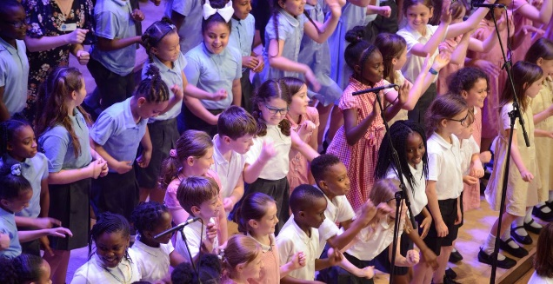

Turning of the Year

**Date and Time:** Wed 12 Dec 2018, 6pm

**Location:** Southbank Centre, The Clore Ballroom, Level 2

**Price:** Free

**Description:** Hear the merry voices of local children raised in song at a festive performance by primary school choirs from across the borough of Lewisham.

Part of a year-round vocal programme from Lewisham Music, the *Turning of the Year* performance draws together choirs for a high-energy massed singing performance conducted by Clare Caddick.

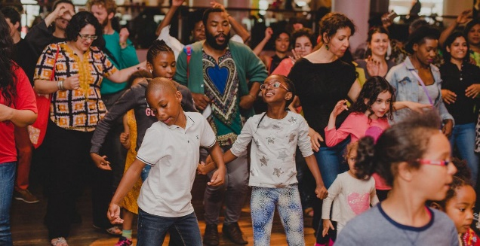

Caribbean Christmas

**Date and Time:** Sat 15 Dec 2018, 12pm

**Location:** Southbank Centre, The Clore Ballroom, Level 2

**Price:** Free

**Description:** Warm up this winter with traditional music, stories and performances from the Caribbean that are typical during the festive season.

We kick off the day in The Clore Ballroom with guest poets and artists performing pieces about holidays in the islands and celebrating West Indian traditions in the UK and abroad.

Stick with us as we move to Queen Elizabeth Hall Foyer after 3pm and pump up the tempo – and the party – Caribbean style.

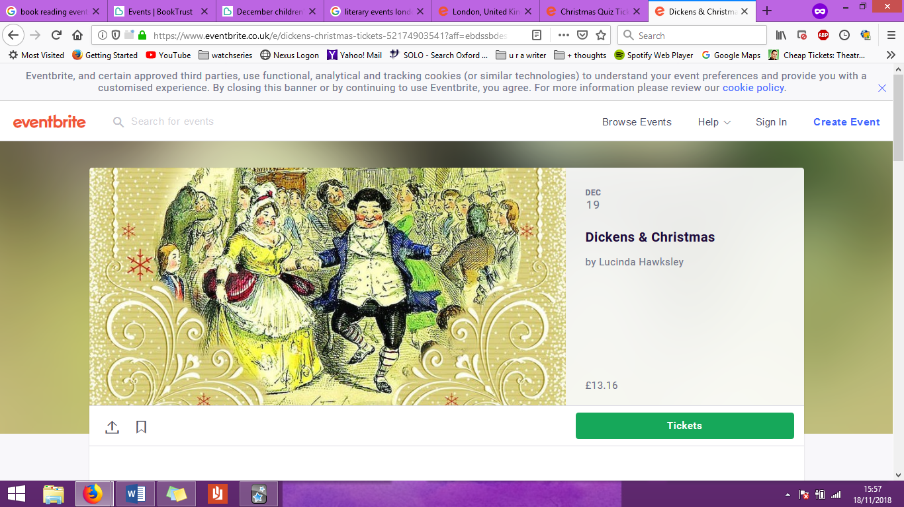

Dickens & Christmas

**Date and Time:** Wed 19 Dec 2018, 2–4pm

**Location:** Outside Holborn tube station, London WC2B 6AA

**Price:** £13.16 (£12 + £1.16 booking fee)

**Description:** Celebrate 175 years of *A Christmas Carol* with a very special walking tour. We’ll visit London locations that inspired Charles Dickens's Christmas writing and look at the beautiful sights of London dressed up for the festive season. The tour will be led by Dickens's great great great granddaughter, Lucinda Hawksley (author of *Dickens and Christmas), and will take place on the anniversary of the book’s publication*.